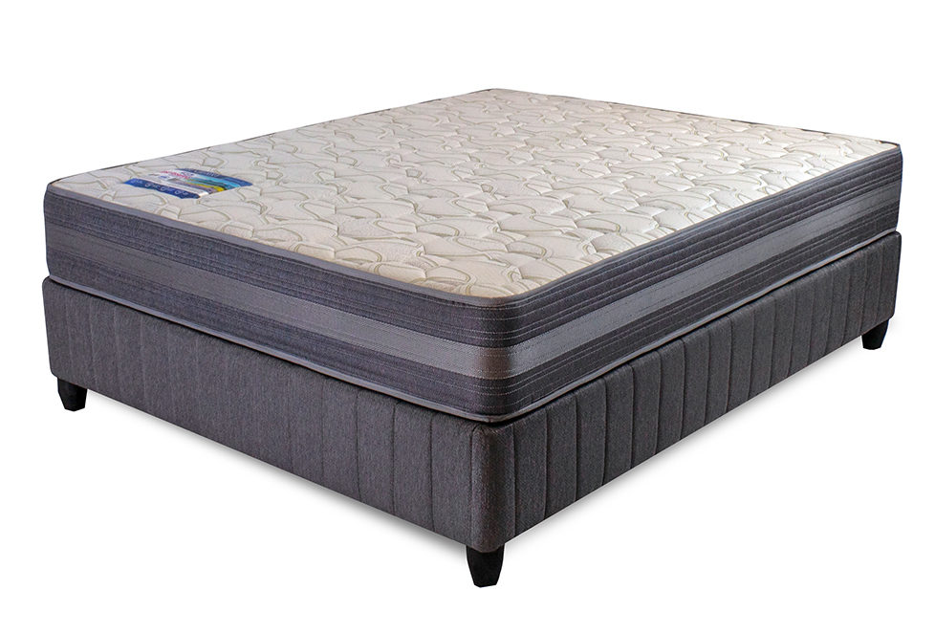


Model : Turnberry Base Set
Supplier/Manufacturer : Rest Assured
Range : Heritage Bonnel Coil Collection
Prices – Bed Set :
- Single Bed Set – R6339
- Three Quarter Bed Set – R7069
- Double Bed Set – R8419
- Queen Bed Set – R8989
- King Bed Set – R11689
Prices – Mattress Only :
- Single Mattress Only – R4689
- Three Quarter Mattress Only – R5239
- Double Mattress Only – R6399
- Queen Mattress Only – R6909
- King Mattress Only – R8379
Prices - Extra Length Bed Set :
- Single Extra Length Bed Set – R6849
- Three Quarter Extra Length Bed Set – R7639
- Double Extra Length Bed Set – R9099
- Queen Extra Length Bed Set – R9709
- King Extra Length Bed Set – R12629
Prices - Extra Length Mattress Only :
- Single Extra Length Mattress Only – R5069
- Three Quarter Extra Length Mattress Only – R5659
- Double Extra Length Mattress Only – R6909
- Queen Extra Length Mattress Only – R7469
- King Extra Length Mattress Only – R9049

Rest Assured Link - https://restassured.co.za/our-ranges/heritage/turnberry/

